DCXA TESTING

Errors..

1. Size of Sub-heading [INFORMATION OF TOKENS] should be large words &size of the heading.

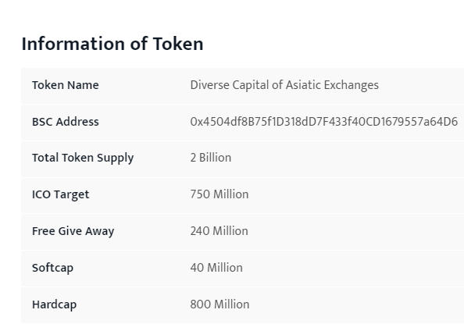

1. Use a image in the 2nd slide

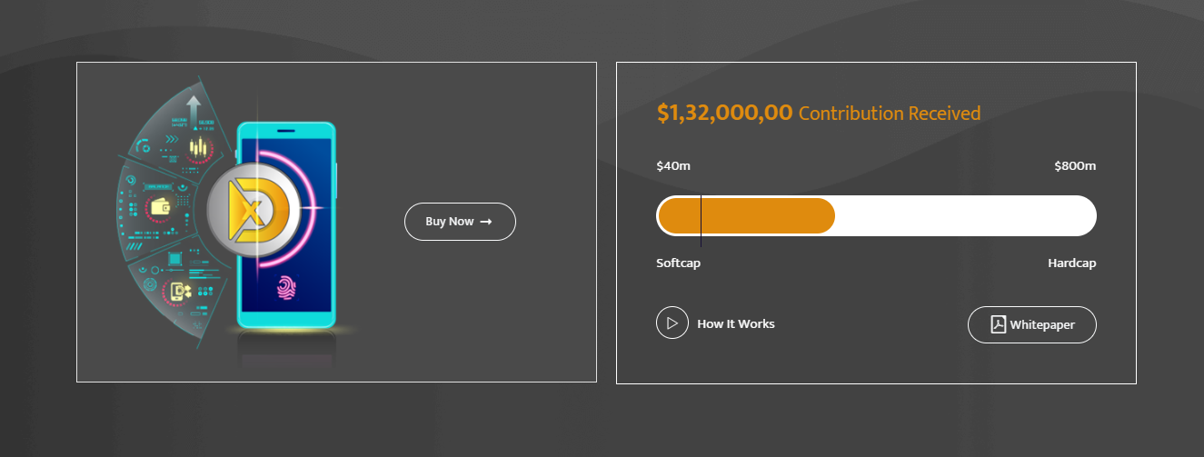

Use this background image ..

c) ICO PHASE 1 AND ICO PHASE 2 shown in the boxes should be stop after we use cursor on the boxes.

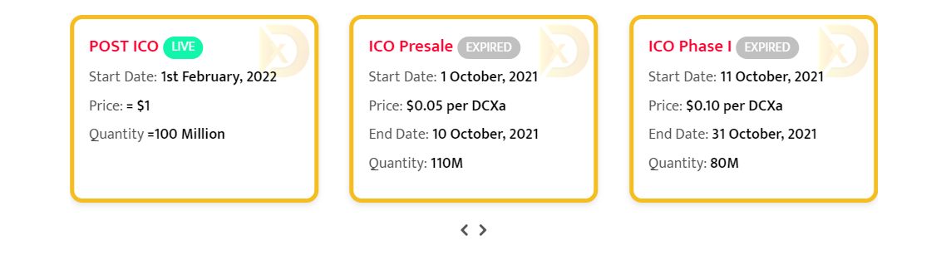

1. 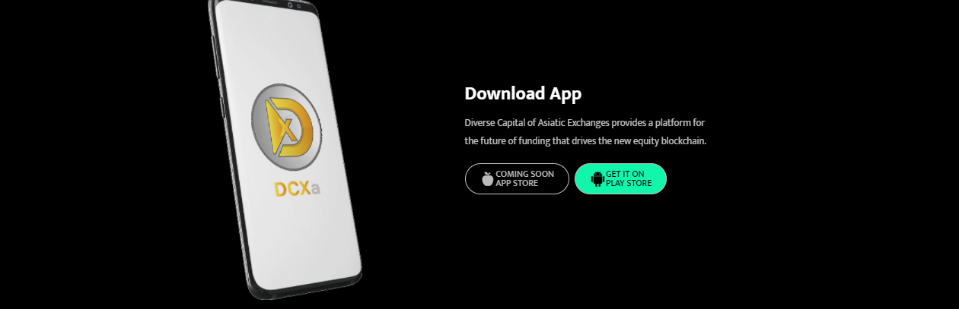We can add a background image to make it more good here image we use
2. Color of the file should be in Blue/red if it is pdf for this slide:

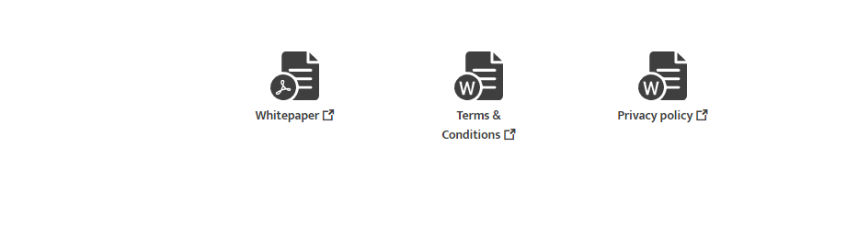

1. we can show this slide of image with more proper way here:

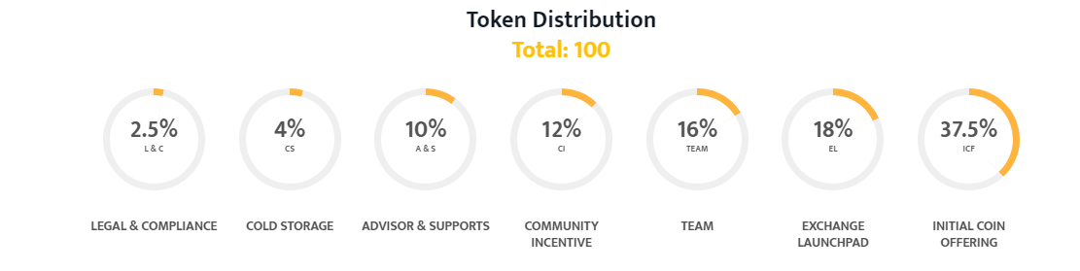

Just like this

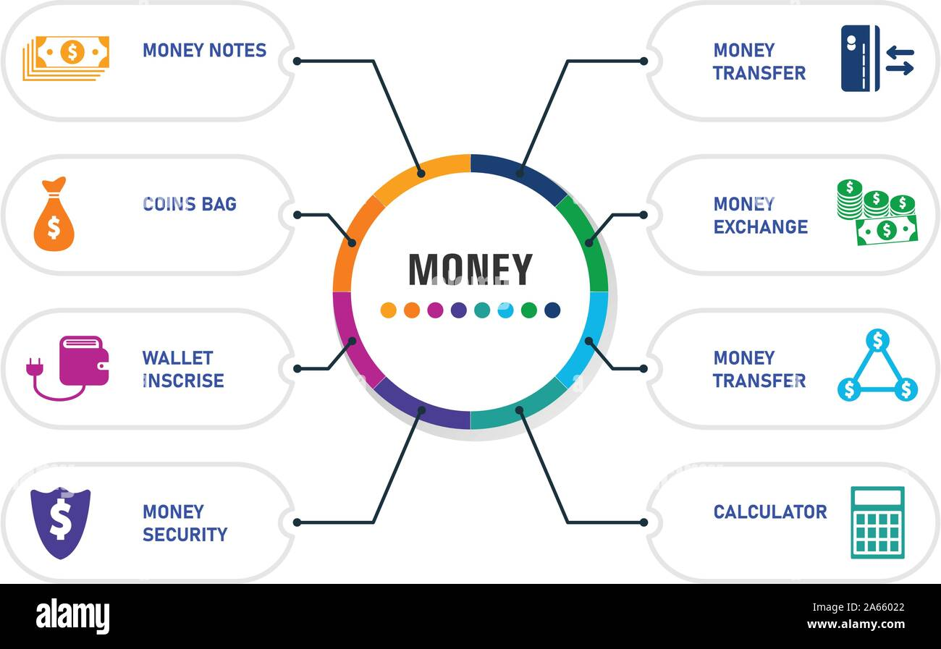

Size should be large.

1. Use a image in between this image



And adding this image

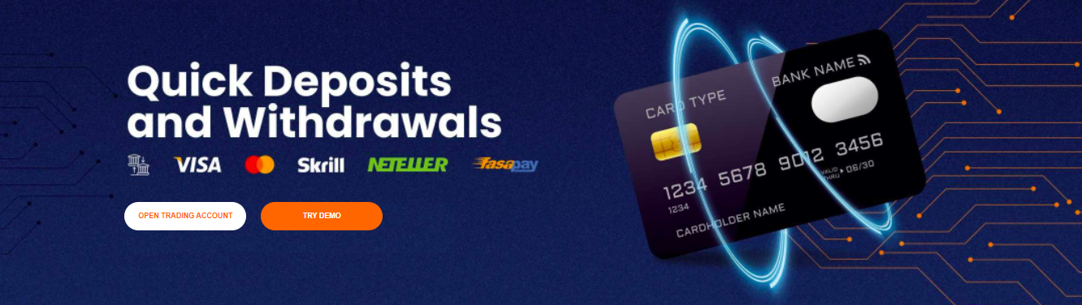

g)use a image before this image

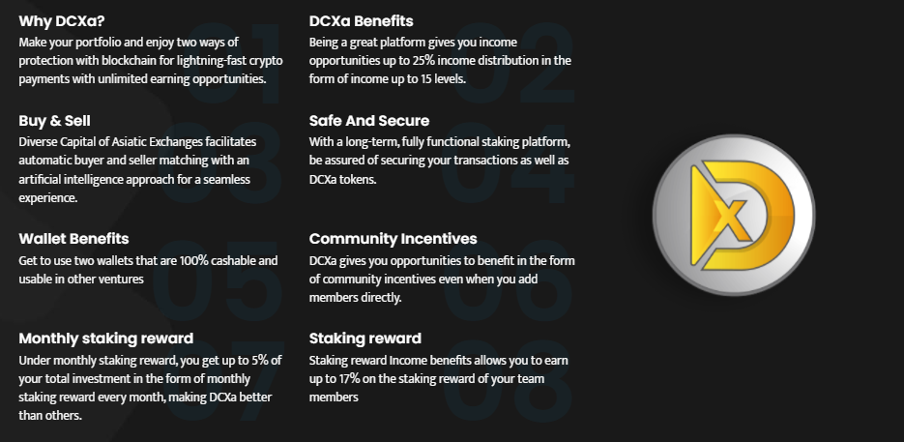

image:



1. Take a look on Subheading fonts should be larger in size

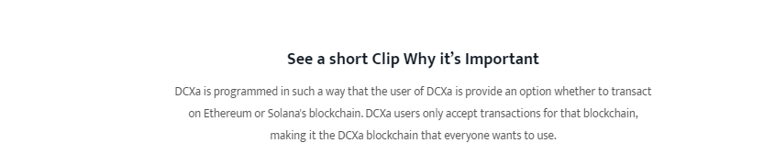

1. Take a look on last point of the FAQ does not seen the paragraph After clicking here:

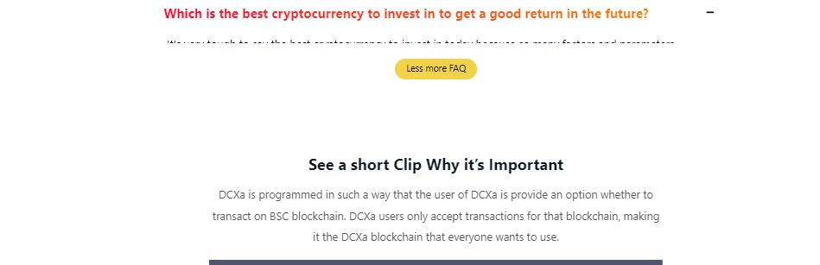

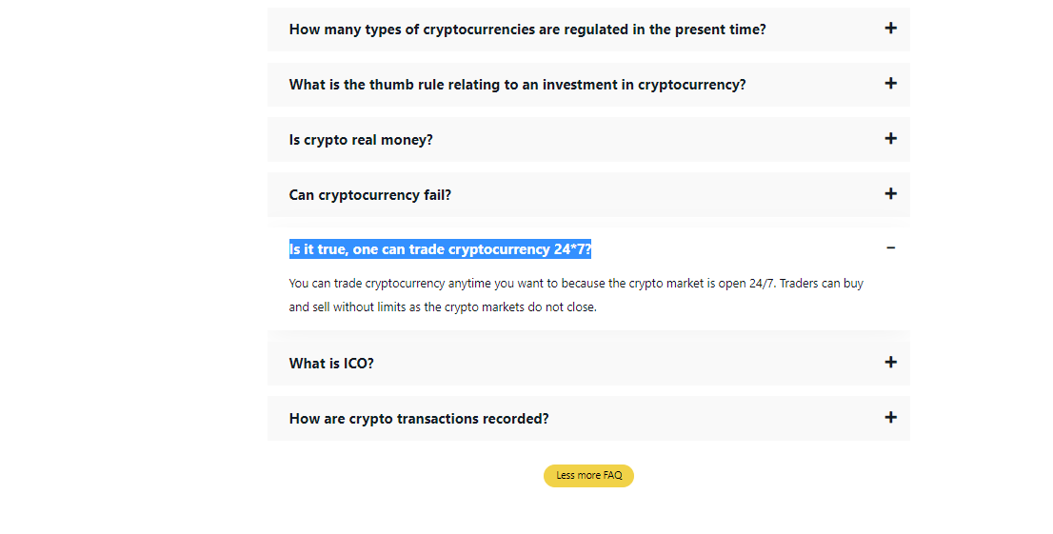

Only in the homepage .

1. The logos of social site app should be shown just like others in the link of contact it does look like similar of others

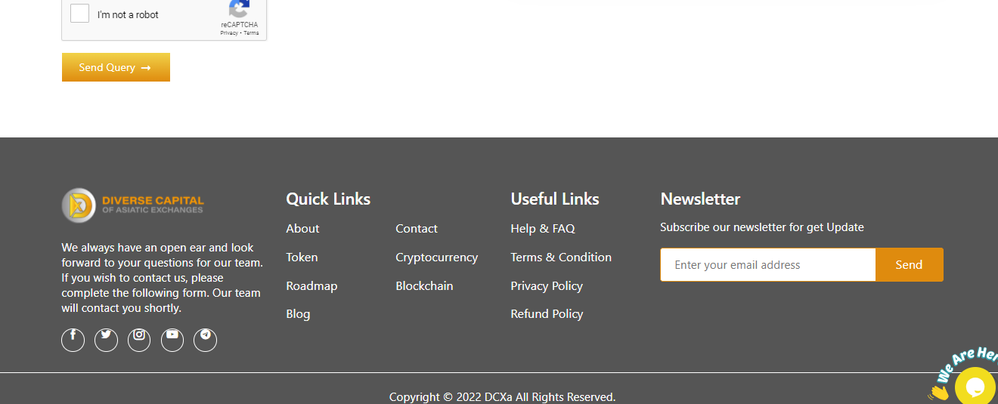

Logos goes up seen like this

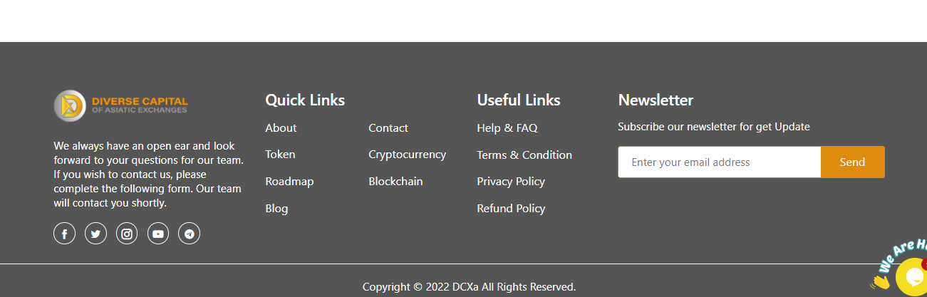

Perfect

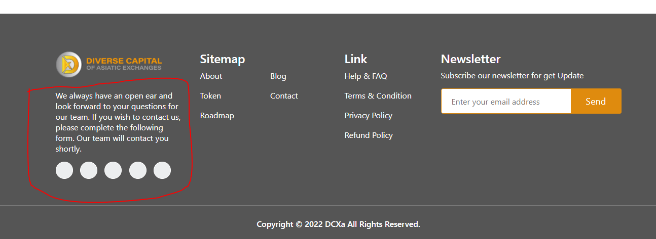

After opening blog we have seen the font size of words as shown in the figure should be different from others and also the links of social site is not showing as comparison to others

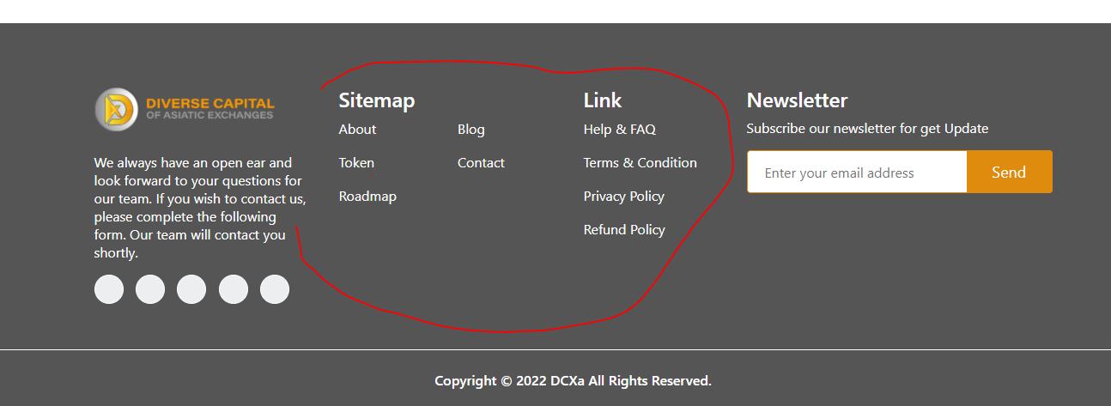

Does not similar like this

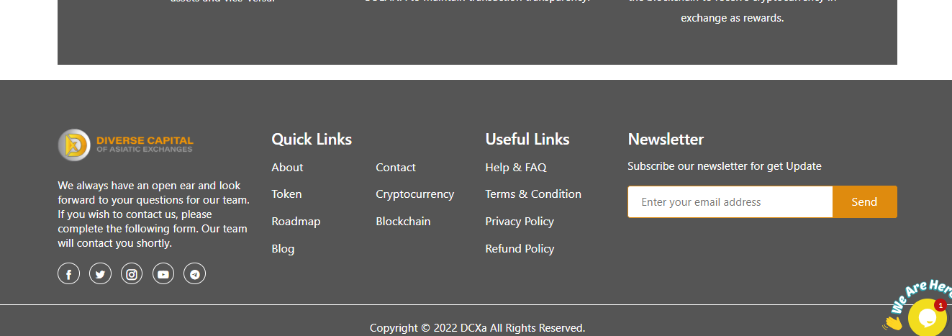

1. Sitemap = quicklinks

Full written words are wrong not similar to other

1. After opening about when we go to down the font size of the words should not be same as of other here are:

After seeing this words it looks different with size.

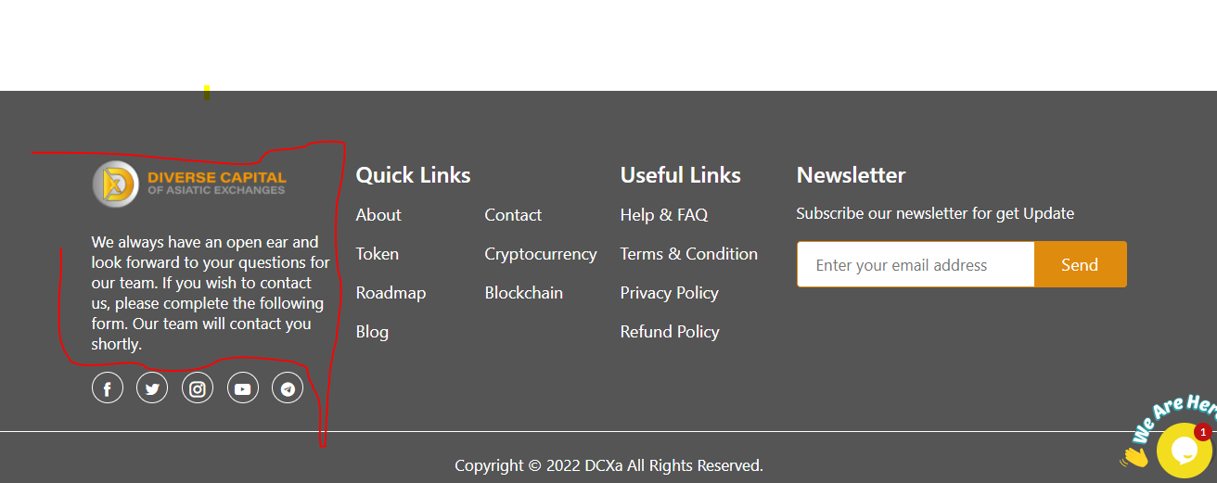

Also when we opening roadmap link it also shown same mistake

Also open cryptocurrency see in the last same as above

Also after opening blockchain same as above

Also FAQ

* choose a same text size in the site specially in the last image shown in the up.

Also in the term and condition same issue

Also privacy policy

Also refund policy link

Planning

Also in thr planning and distribution

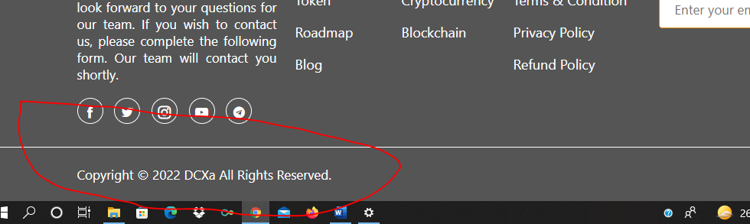

Th highlight words should be in centre just like other and this error shown in the three links like

* TERMS AND CONDITION
* PRIVACY POLICY
* REFUND POLICY